COURSE CODE/TITLE: | CPE 010 |  | SECTION: | CPE21S3
DATE PERFORMED: | 7/7/26 |  | DATE SUBMITTED: | 7/8/26
NAME: | Ralf Nicolo B. Abello |  | INSTRUCTOR: | Engr. Jimlord Quejado

ACTIVITY NO. 1.1 | Algorithm, Flowchart, Pseudocode
1. PROCEDURE OUTPUT
Task 1
Algorithm:
- Input the three quiz scores: Quiz1, Quiz2, Quiz3
- Compute Total = Quiz1 + Quiz2 + Quiz3
- Compute Average = Total / 3
- Display Total and Average

Pseudocode:
BEGIN
DECLARE quiz1, quiz2, quiz3
DECLARE total, average

DISPLAY "Enter Quiz 1 score: "
INPUT quiz1
DISPLAY "Enter Quiz 2 score: "
INPUT quiz2
DISPLAY "Enter Quiz 3 score: "
INPUT quiz3

total = quiz1 + quiz2 + quiz3
average = total / 3

DISPLAY "Total Score: ", total
DISPLAY "Average Score: ", average
END

Flowchart:
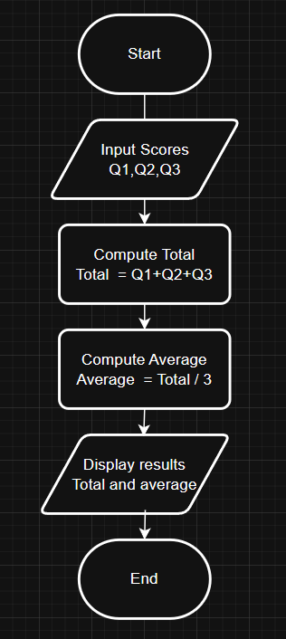

C++ Program:
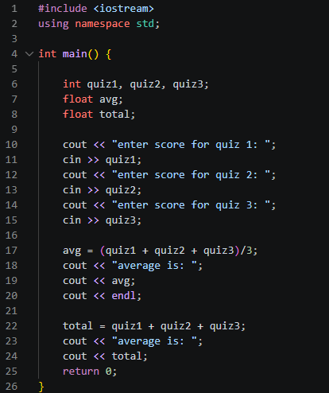

Output:
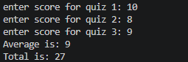
Code Analysis:
This C++ program asks the user to enter the scores for three quizzes and stores them in separate variables. It then calculates the average by adding the three scores and dividing the result by three, and displays the average on the screen. After that, the program computes the total score by adding all three quiz scores together and prints the result. The program demonstrates the basic use of variables, user input, arithmetic operations, and output statements to process and display quiz results.

Task 2
Algorithm:
- Display Pizza Palace menu (item names only, no prices)
- Input the price of Pepperoni Supreme
- Input the price of Hawaiian Delight
- Input the price of Margherita Classic
- Compute Total = price1 + price2 + price3
- Input Payment from customer
- Compute Change = Payment − Total
- Display the order receipt (items, prices, total, payment, change)

Pseudocode:
BEGIN
DECLARE item1, item2, item3 AS STRING = "Pepperoni Supreme", "Hawaiian Delight", "Margherita Classic"
DECLARE price1, price2, price3
DECLARE total, payment, change

DISPLAY "===== RALF PIZZA PLACE ====="
DISPLAY "1. ", item1
DISPLAY "2. ", item2
DISPLAY "3. ", item3

DISPLAY "Enter price of ", item1, ": "
INPUT price1
DISPLAY "Enter price of ", item2, ": "
INPUT price2
DISPLAY "Enter price of ", item3, ": "
INPUT price3

total = price1 + price2 + price3
DISPLAY "Total bill: ", total

DISPLAY "Enter payment amount: "
INPUT payment

change = payment - total

DISPLAY "----- ORDER RECEIPT -----"
DISPLAY item1, ": ", price1
DISPLAY item2, ": ", price2
DISPLAY item3, ": ", price3
DISPLAY "Total: ", total
DISPLAY "Payment: ", payment
DISPLAY "Change: ", change
END

Flowchart:
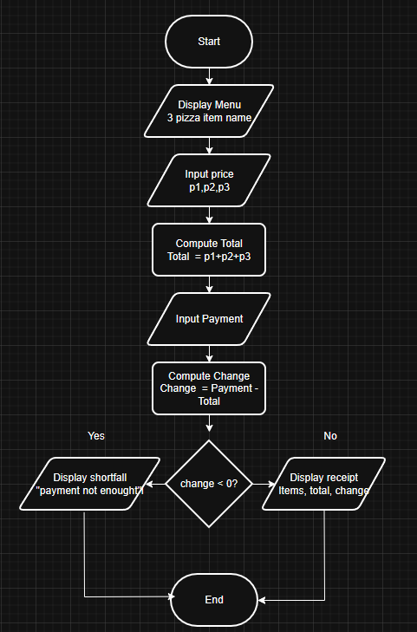

C++ Program:
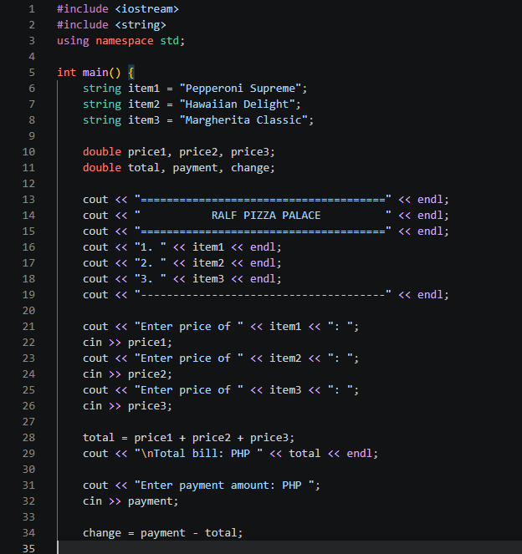
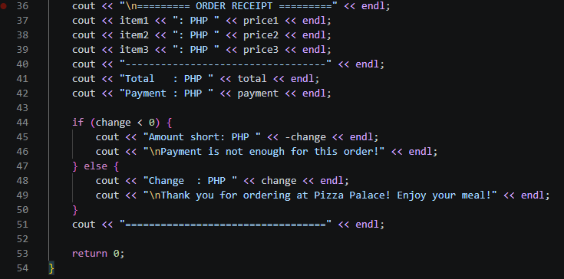

Output:
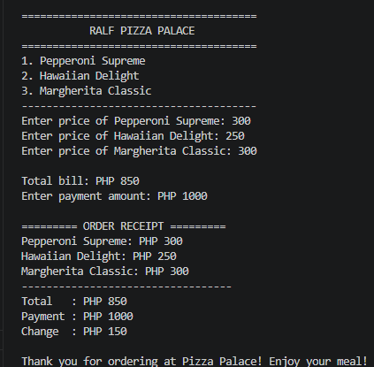

Code Analysis:
This C++ program simulates a simple pizza ordering and billing system for a pizza shop. It begins by creating three string variables to store the names of the pizza menu items and several double variables to store their prices, the total bill, the customer's payment, and the change. The program then displays a formatted menu with the available pizza choices and prompts the user to enter the price of each item. After receiving the inputs, it calculates the total bill by adding the three prices together and displays the total amount. Next, it asks the customer to enter the payment amount and computes the change by subtracting the total bill from the payment. The program then prints a detailed receipt showing each pizza item with its corresponding price, the total bill, and the amount paid by the customer. Finally, it uses an if-else statement to determine whether the payment is sufficient. If the payment is less than the total bill, it displays the amount still owed and informs the customer that the payment is insufficient. Otherwise, it displays the correct change and prints a thank-you message. The program demonstrates the use of variables, strings, user input and output, arithmetic calculations, conditional statements, and formatted text to create a simple but functional point-of-sale system.

2. ANSWERS TO SUPPLEMENTAL ACTIVITY
Copy and paste the questions from the lab and include your answers after.

3. ARTIFICIAL INTELLIGENCE (AI) USE DISCLOSURE STATEMENT
I hereby declare that artificial intelligence (AI) tools were used, if applicable, in the preparation of this academic work. The following indicates the nature and extent of AI assistance:

Tools Used: | ChatGPT
Examples: ChatGPT, Microsoft Copilot, Grammarly, QuillBot, etc.

Purpose of Use: | Grammar Correction
Examples: grammar correction, idea generation, formatting, summarization, code assistance, explanation of concepts, etc.

Extent of Use: | I pasted my original code analysis to help me structure my code analysis better
Explain how AI was used and confirm that it did not replace original thinking, analysis, authorship, or completion of the required work.

By submitting this activity, I affirm that my use of AI complies with T.I.P.’s AI usage policy and does not exceed the permitted limits for similarity, automated content generation, or academic assistance.

I understand that any false, incomplete, or misleading disclosure may be subject to investigation in accordance with due process and may result in sanctions for violation of existing T.I.P. policies.

Lab activities, templates, and related instructional materials shall not be reuploaded, reproduced, distributed, or shared with external organizations or third parties without the prior express written permission of the Technological Institute of the Philippines.

